1. Startup page looks like this consisting of Album Names

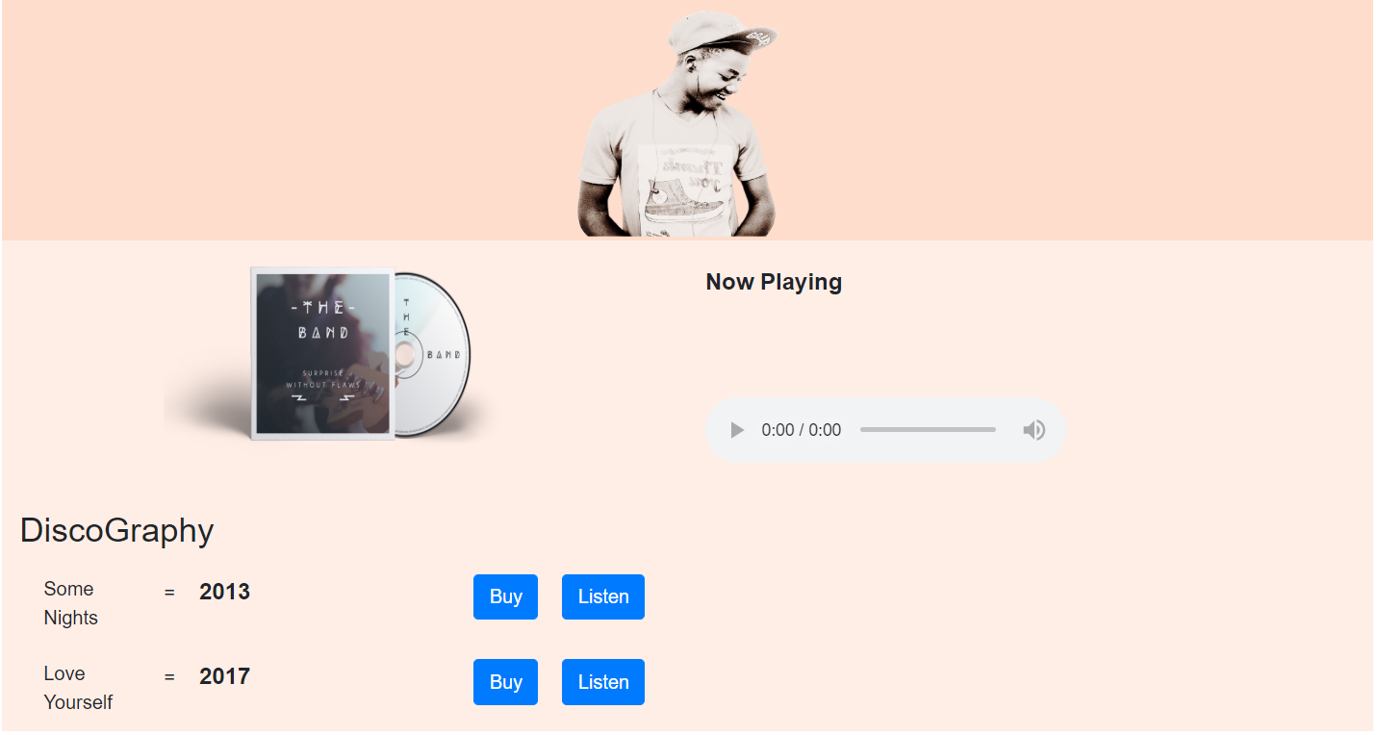

1. On clicking **Listen Button**, songs in the album will be displayed underneath music player

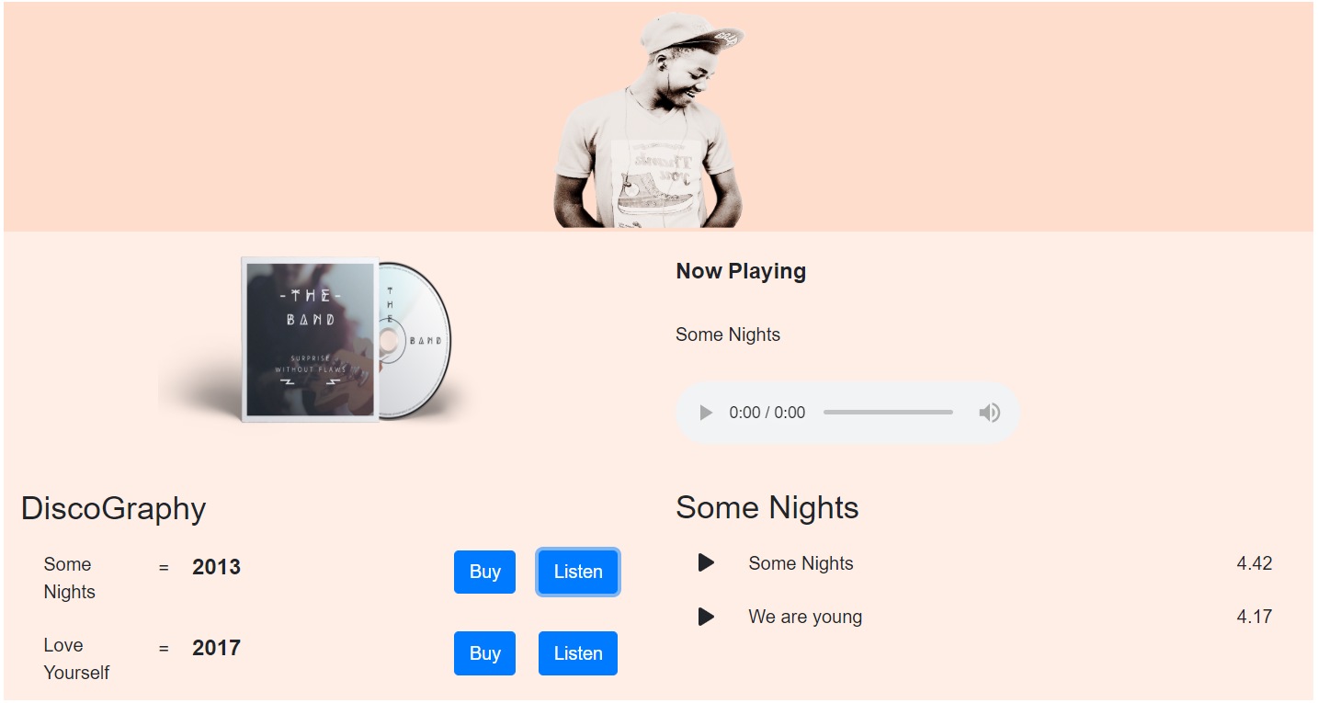

1. When you click on **play icon** song will play

